# 4.4 Rotation Matrices in 2-Dimensions

## The Rotation Matrix

To this point, we worked with vectors and with matrices. Now, we will put them together to see how to use a matrix multiplication to rotate a vector in the counterclockwise direction through some angle $θ$ in 2-dimensions.

|  |  |
| --- | --- |
| Diagram of a vector v in a coordinate system and its counterclockwise rotation through some angle. | Diagram of a vector v and its rotational  vector v prime. Vector v is rotated counterclockwise through an angle and v prime is new vector after the rotation. |

Our plan is to rotate the vector $v=\left[\begin{matrix}x \\ y\end{matrix}\right]$ counterclockwise through some angle $θ$ to the new position given by the vector $v^{'}=\left[{\begin{matrix}x \\ y^{'}\end{matrix}}^{'}\right]$. To do so, we use the rotation matrix, a matrix that rotates points in the $xy$-plane counterclockwise through an angle $θ$ relative to the $x$-axis.

$$\left[\begin{matrix}cosθ & -sinθ \\ sinθ & cosθ\end{matrix}\right]$$

## The Rotation Process

To get the coordinates of the new vector $\left[{\begin{matrix}x \\ y^{'}\end{matrix}}^{'}\right],$ perform the matrix multiplication

$$\left[{\begin{matrix}x \\ y^{'}\end{matrix}}^{'}\right]=\left[\begin{matrix}cosθ & –sinθ \\ sinθ & cosθ\end{matrix}\right]\left[\begin{matrix}x \\ y\end{matrix}\right]$$

Find the vector $\left[{\begin{matrix}x \\ y^{'}\end{matrix}}^{'}\right]$ that results when the vector $\left[\begin{matrix}x \\ y\end{matrix}\right]=\left[\begin{matrix}1 \\ –1\end{matrix}\right]$ is rotated 90° counterclockwise.

Example (1)

Using the rotation formula $\left[{\begin{matrix}x \\ y^{'}\end{matrix}}^{'}\right]=\left[\begin{matrix}cosθ & -sinθ \\ sinθ & cosθ\end{matrix}\right]\left[\begin{matrix}x \\ y\end{matrix}\right]$ with $\left[\begin{matrix}x \\ y\end{matrix}\right]=\left[\begin{matrix}1 \\ –1\end{matrix}\right]$

and $θ=90°,$ we get

$\left[{\begin{matrix}x \\ y^{'}\end{matrix}}^{'}\right]=\left[\begin{matrix}cosθ & –sinθ \\ sinθ & cosθ\end{matrix}\right]\left[\begin{matrix}x \\ y\end{matrix}\right]=\left[\begin{matrix}cos90° & –sin90° \\ sin90° & cos90°\end{matrix}\right]\left[\begin{matrix}1 \\ –1\end{matrix}\right]$

$\left[{\begin{matrix}x \\ y^{'}\end{matrix}}^{'}\right]=\left[\begin{matrix}0 & –1 \\ 1 & 0\end{matrix}\right]\left[\begin{matrix}1 \\ -1\end{matrix}\right]=\left[\begin{matrix}0∙1+\left(–1\right)∙\left(–1\right) \\ 1∙1+0∙\left(–1\right)\end{matrix}\right]$

$\left[{\begin{matrix}x \\ y^{'}\end{matrix}}^{'}\right]=\left[\begin{matrix}1 \\ 1\end{matrix}\right]$

When rotated counterclockwise 90°, the vector $\left[\begin{matrix}1 \\ –1\end{matrix}\right]$ becomes .

|  |  |
| --- | --- |
| Diagram showing vector (1,-1). | Diagram showing vector (1,-1) and a new vector (1,1) after vector (1,-1) is rotated counterclockwise through 90 degrees. |

Find the vector $\left[{\begin{matrix}x \\ y^{'}\end{matrix}}^{'}\right]$ that results when the vector $\left[\begin{matrix}x \\ y\end{matrix}\right]=\left[\begin{matrix}2 \\ 6\end{matrix}\right]$ is rotated 60° counterclockwise.

Example (2)

Using the rotation formula $\left[{\begin{matrix}x \\ y^{'}\end{matrix}}^{'}\right]=\left[\begin{matrix}cosθ & -sinθ \\ sinθ & cosθ\end{matrix}\right]\left[\begin{matrix}x \\ y\end{matrix}\right]$ with $\left[\begin{matrix}x \\ y\end{matrix}\right]=\left[\begin{matrix}2 \\ 6\end{matrix}\right]$ and $θ=60°,$ we get

$\left[{\begin{matrix}x \\ y^{'}\end{matrix}}^{'}\right]=\left[\begin{matrix}cosθ & –sinθ \\ sinθ & cosθ\end{matrix}\right]\left[\begin{matrix}x \\ y\end{matrix}\right]=\left[\begin{matrix}cos60° & –sin60° \\ sin60° & cos60°\end{matrix}\right]\left[\begin{matrix}2 \\ 6\end{matrix}\right]$

$\left[{\begin{matrix}x \\ y^{'}\end{matrix}}^{'}\right]=\left[\begin{matrix}1/2 & –\sqrt{3}/2 \\ \sqrt{3}/2 & 1/2\end{matrix}\right]\left[\begin{matrix}2 \\ 6\end{matrix}\right]=\left[\begin{matrix}1/2∙2+\left(–\sqrt{3}/2\right)∙6 \\ \sqrt{3}/2∙2+1/2∙6\end{matrix}\right]$

$\left[{\begin{matrix}x \\ y^{'}\end{matrix}}^{'}\right]=\left[\begin{matrix}1–3\sqrt{3} \\ 3+\sqrt{3}\end{matrix}\right]$

When rotated counterclockwise 60°, the vector $\left[\begin{matrix}2 \\ 6\end{matrix}\right]$ becomes .

|  |  |
| --- | --- |
| Diagram showing vector (2,6). | Diagram showing vector (2,6) and a new vector (-4.20,4.73) after vector (2,6) is rotated counterclockwise 60 degrees. |

## Using Technology

We can use technology to help us find the rotation. WolframAlpha evaluates the trig functions for us.

Go to www.wolframalpha.com.

We can check the above problem from Example 2 by using WolframAlpha. Find the vector $\left[{\begin{matrix}x \\ y^{'}\end{matrix}}^{'}\right]$ that results when the vector $\left[\begin{matrix}x \\ y\end{matrix}\right]=\left[\begin{matrix}2 \\ 6\end{matrix}\right]$ is rotated 60° counterclockwise.

To find rotation of the vector enter Evaluate [ [cos(60), –sin(60)], [sin(60), cos(60)] ] * [ 2,6 ] into the entry field. Both entries and rows are separated by commas and W|A does not see spaces.

WolframAlpha tells you what it thinks you entered, then it shows you the answer.

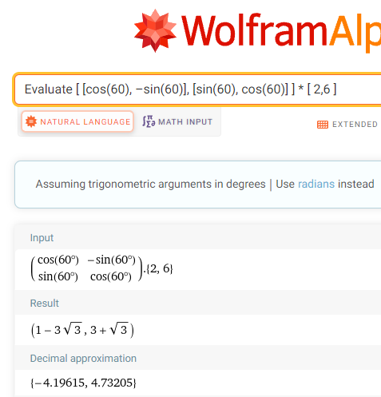

When rotated counterclockwise 60°, the vector $\left[\begin{matrix}2 \\ 6\end{matrix}\right]$ becomes $\left[\begin{matrix}1–3\sqrt{3} \\ 3+\sqrt{3}\end{matrix}\right]≈\left[\begin{matrix}–4.20 \\ 4.73\end{matrix}\right]$

## EXAMPLES

1. $\left[\begin{matrix}x \\ y\end{matrix}\right]=\left[\begin{matrix}1 \\ 1\end{matrix}\right]$ through 90°. ANS: $\left[\begin{matrix}–1 \\ 1\end{matrix}\right]$
2. $\left[\begin{matrix}x \\ y\end{matrix}\right]=\left[\begin{matrix}1 \\ 1\end{matrix}\right]$ through 180°. ANS: $\left[\begin{matrix}–1 \\ –1\end{matrix}\right]$
3. $\left[\begin{matrix}x \\ y\end{matrix}\right]=\left[\begin{matrix}1 \\ 1\end{matrix}\right]$ through 270°. ANS: $\left[\begin{matrix}1 \\ –1\end{matrix}\right]$
4. $\left[\begin{matrix}x \\ y\end{matrix}\right]=\left[\begin{matrix}0 \\ 1\end{matrix}\right]$ through 90°. ANS: $\left[\begin{matrix}1 \\ 0\end{matrix}\right]$
5. $\left[\begin{matrix}x \\ y\end{matrix}\right]=\left[\begin{matrix}1 \\ 1\end{matrix}\right]$ through 45°. ANS: $\left[\begin{matrix}0 \\ \sqrt{2}\end{matrix}\right]$
6. $\left[\begin{matrix}x \\ y\end{matrix}\right]=\left[\begin{matrix}–1 \\ 1\end{matrix}\right]$ through 45°. ANS: $\left[\begin{matrix}-\sqrt{2} \\ 0\end{matrix}\right]$
7. $\left[\begin{matrix}x \\ y\end{matrix}\right]=\left[\begin{matrix}–2.20205 \\ 4.48898\end{matrix}\right]$ through $-63$ °. ANS: $\left[\begin{matrix}3 \\ 4\end{matrix}\right]$
8. $\left[\begin{matrix}x \\ y\end{matrix}\right]=\left[\begin{matrix}–3 \\ –3\end{matrix}\right]$ through $-90$ °. ANS: $\left[\begin{matrix}–3 \\ 3\end{matrix}\right]$
9. Approximate, to five decimal places, the coordinates of the vector $\left[\begin{matrix}x \\ y\end{matrix}\right]=\left[\begin{matrix}–1 \\ 1\end{matrix}\right]$ when it is rotated counterclockwise 30°.

ANS: $\left[\begin{matrix}–1.36603 \\ 0.36603\end{matrix}\right]$

## Note to Instructor

Note that we plan to rotate some vector $v=\left[\begin{matrix}x \\ y\end{matrix}\right]$ through some angle $θ$ to the new position given by the vector $v^{'}=\left[{\begin{matrix}x \\ y^{'}\end{matrix}}^{'}\right]$, and to do so, we will use the rotation matrix, a matrix that rotates points in the $xy$-plane counterclockwise through an angle $θ$ relative to the $x$-axis.

$$\left[\begin{matrix}cosθ & -sinθ \\ sinθ & cosθ\end{matrix}\right]$$

Consider demonstrating these rotations:

1. Find the vector $\left[{\begin{matrix}x \\ y^{'}\end{matrix}}^{'}\right]$ that results when the vector $\left[\begin{matrix}x \\ y\end{matrix}\right]=\left[\begin{matrix}5 \\ –5\end{matrix}\right]$ is rotated 90° counterclockwise.

Using the rotation formula $\left[{\begin{matrix}x \\ y^{'}\end{matrix}}^{'}\right]=\left[\begin{matrix}cosθ & -sinθ \\ sinθ & cosθ\end{matrix}\right]\left[\begin{matrix}x \\ y\end{matrix}\right]$ with $\left[\begin{matrix}x \\ y\end{matrix}\right]=\left[\begin{matrix}5 \\ –5\end{matrix}\right]$ and $θ=90°,$ we get

$\left[{\begin{matrix}x \\ y^{'}\end{matrix}}^{'}\right]=\left[\begin{matrix}cosθ & -sinθ \\ sinθ & cosθ\end{matrix}\right]\left[\begin{matrix}x \\ y\end{matrix}\right]=\left[\begin{matrix}cos90° & -sin90° \\ sin90° & cos90°\end{matrix}\right]\left[\begin{matrix}5 \\ –5\end{matrix}\right]$

$\left[{\begin{matrix}x \\ y^{'}\end{matrix}}^{'}\right]=\left[\begin{matrix}0 & –1 \\ 1 & 0\end{matrix}\right]\left[\begin{matrix}5 \\ –5\end{matrix}\right]=\left[\begin{matrix}0∙5+(–1)∙(–5) \\ 1∙5+0∙(–5)\end{matrix}\right]$

$\left[{\begin{matrix}x \\ y^{'}\end{matrix}}^{'}\right]=\left[\begin{matrix}5 \\ 5\end{matrix}\right]$

When rotated counterclockwise 90°, the vector $\left[\begin{matrix}5 \\ –5\end{matrix}\right]$ becomes $\left[\begin{matrix}5 \\ 5\end{matrix}\right]$.

* If your class knows some trig, you can show the conversion of

$\left[\begin{matrix}cos90° & -sin90° \\ sin90° & cos90°\end{matrix}\right]$ to $\left[\begin{matrix}0 & –1 \\ 1 & 0\end{matrix}\right]$

Since $cos90°=0 and sin90°=1$

* If trig is a challenge, use WolframAlpha to perform the matrix multiplication.

Go to www.wolframalpha.com.

To find rotation of the vector, enter Evaluate [ [cos(90), –sin(90)], [sin(90), cos(90)] ] * [ 5, -5] into the entry field. WolframAlpha tells you what it thinks you entered, then tells you its answer.

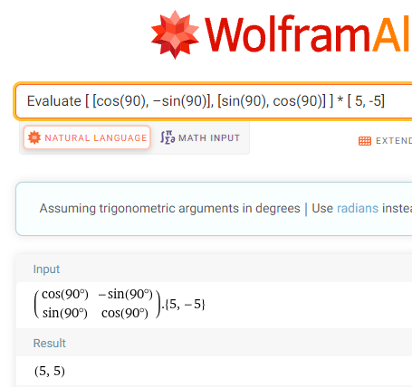

Be sure to write a conclusion so your students know to do so.

When rotated counterclockwise 90°, the vector $\left[\begin{matrix}5 \\ –5\end{matrix}\right]$ becomes $\left[\begin{matrix}5 \\ 5\end{matrix}\right]$.

1. The rotation formula works for clockwise rotations. We just need to make the angle of rotation negative.

Find the vector $\left[{\begin{matrix}x \\ y^{'}\end{matrix}}^{'}\right]$ that results when the vector $\left[\begin{matrix}x \\ y\end{matrix}\right]=\left[\begin{matrix}0 \\ –1\end{matrix}\right]$ is rotated –270°.

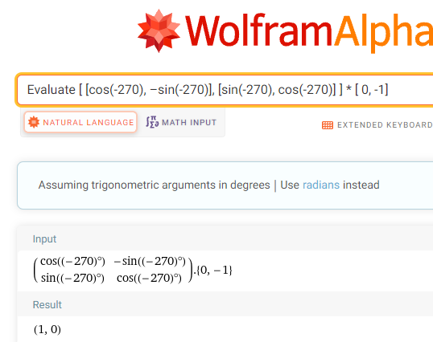

When rotated clockwise 90°, the vector $\left[\begin{matrix}0 \\ –1\end{matrix}\right]$ becomes $\left[\begin{matrix}1 \\ 0\end{matrix}\right]$.

## Deriving the Rotation Formula

If your class knows some trig, you may wish to derive the rotation formula.

$$\left[{\begin{matrix}x \\ y^{'}\end{matrix}}^{'}\right]=\left[\begin{matrix}cosθ & –sinθ \\ sinθ & cosθ\end{matrix}\right]\left[\begin{matrix}x \\ y\end{matrix}\right]$$

We wish to derive a formula that rotates a vector $v=\left[\begin{matrix}x \\ y\end{matrix}\right]$ counterclockwise through some angle $θ$ to the new position given by the vector $v^{'}=\left[{\begin{matrix}x \\ y^{'}\end{matrix}}^{'}\right]$.

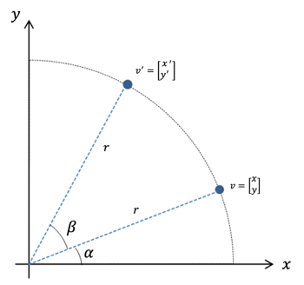

We wish to rotate the vector $v=\left[\begin{matrix}x \\ y\end{matrix}\right]$ through an angle $β$ around the origin.

We know that in general,

$$cosθ=\frac{adjacent}{hypotenuse} \& sinθ=\frac{opposite}{hypotenuse}$$

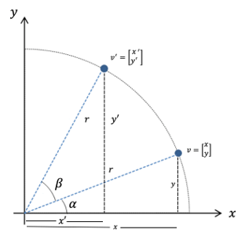

The figure shows that for angle $α$, $$\left\{\begin{matrix}cosα=\frac{x}{r} \\ sinα=\frac{y}{r}\end{matrix}\right. → \left\{\begin{matrix}x=r∙ cosα \\ y=r∙ sinα\end{matrix}\right.$$

Also

$$\left\{\begin{matrix}cos\left(α+β\right)=\frac{x'}{r} \\ sin\left(α+β\right)=\frac{y'}{r}\end{matrix}\right. → \left\{\begin{matrix}x'=r∙ cos\left(α+β\right) \\ y'=r∙ sin\left(α+β\right)\end{matrix}\right.$$

By the trigonometry addition identity,

$$cos\left(α+β\right)= cosα∙cosβ-sinα∙ sinβ$$

$x'=r∙ cos\left(α+β\right)$

$=r∙ \left(cosα∙cosβ-sinα∙ sinβ\right)$ $=r∙ cosα cosβ-r∙sinα sinβ$ Then, since $x=r∙ cosα$ and $y=r∙ sinα$

Replace with $x$ and with $y$

$x^{'}=x∙ cosβ- y ∙sinβ$

Similarly, by the trigonometry addition identity,

$$sin\left(α+β\right)=sinα∙cosβ+cosα∙ sinβ$$

$y'=r∙ sin\left(α+β\right)$

$=r∙ \left(sinα∙cosβ+cosα∙ sinβ\right)$

$=r∙ sinα cosβ+r∙cosα sinβ$ Then, since $y=r∙ sinα$ and $x=r∙ cosα$

Replace with $y$ and with $x$

$y^{'}=y∙ cosβ+ x ∙sinβ$

Rewrite this as $y^{'}= x ∙sinβ+y∙ cosβ$

Now we have $\left\{\begin{matrix}x^{'}=x∙ cosβ- y ∙sinβ \\ y^{'}= x ∙sinβ+y∙ cosβ \end{matrix}\right.$

Putting these two results into matrix form, $\left[{\begin{matrix}x \\ y^{'}\end{matrix}}^{'}\right]=\left[\begin{matrix}cosβ & -sinβ \\ sinβ & cosβ\end{matrix}\right]\left[\begin{matrix}x \\ y\end{matrix}\right]$.

Replacing $β$ with $θ$ to match our notation, we get $\left[{\begin{matrix}x \\ y^{'}\end{matrix}}^{'}\right]=\left[\begin{matrix}cosθ & -sinθ \\ sinθ & cosθ\end{matrix}\right]\left[\begin{matrix}x \\ y\end{matrix}\right]$

And we have produced the rotation formula.

[4-4_rotation_matrices_in_2_dimensions.docx](https://oer4cte.org/math4gamedevelopers/teacher/4-4_rotation_matrices_in_2_dimensions.docx), attributed to Denny Burzynski (author) and Downey Unified School District (publisher) is licensed under CC BY-NC 4.0. To view a copy of this license, visit https://creativecommons.org/licenses/by-nc/4.0